Scavenger Hunt
Challenge: Scavenger Hunt
Category: Web Exploitation
Difficulty: Easy

STEP 1
Access the web using url http://wily-courier.picoctf.net:60589/
STEP 2
Explore the web using inspect then I found 2 parts of the flag
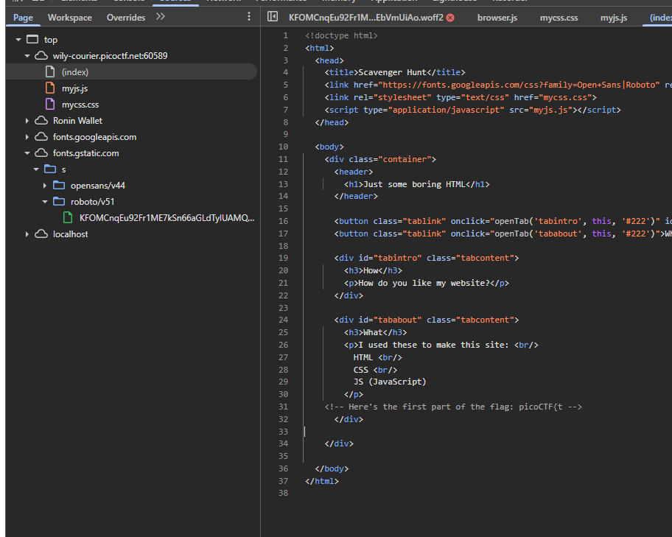
picoCTF{t
h4ts_4_l0
STEP 3
Now I add /robots.txt
Action: Add /robots.txt to the end of the URL.
Result: You’ll find the next part of the flag and a hint about "Apache."
3rd part of the flag
t_0f_pl4c
STEP 4
The Apache Config (/.htaccess)
Since the hint mentioned Apache, we look for the configuration file that controls access to directories.
Action: Change the URL to /[URL]/.htaccess.
Result: You’ll get another piece of the flag and a hint about "Macs."

Part 4: 3s_2_lO0k
STEP 5
The Mac Store (/.DS_Store)
Macs create hidden files called .DS_Store to store folder metadata.
Action: Change the URL to /[URL]/.DS_Store.
Result: This should reveal the final piece of the flag.

Part 5: _9588550}
STEP 6
Combine all parts
FLAG: picoCTF{th4ts_4_l0t_0f_pl4c3s_2_lO0k_9588550}

